Main Menu (definition of settings applicable only for one Domain)
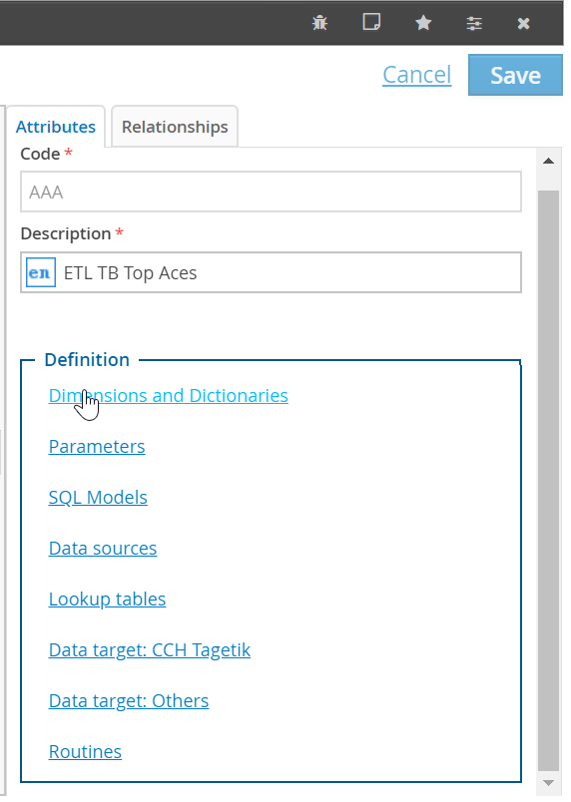
………………………………………………………………………………………………………………………………………………………………………………………….
- Define one element to apply to the full dimension

If one dimension is not included in your data source, you can complete this dimension by:
- Automatic enhancement:
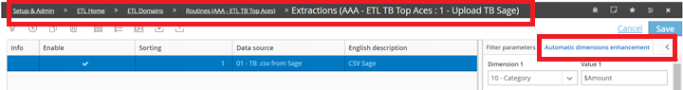
/!\ Content hard coded, can’t be change at each running.

- Transformation filter
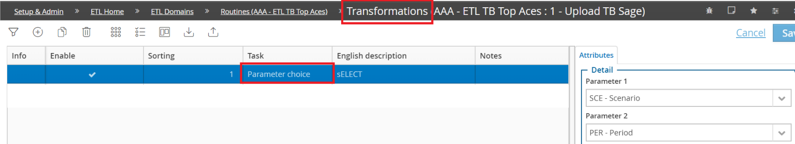
/!\ Filters are defined upstream. But must be activated in the section Transformation as Parameter choice (no data enhancement during extraction and upload phases).

- Currency definition based on Entity
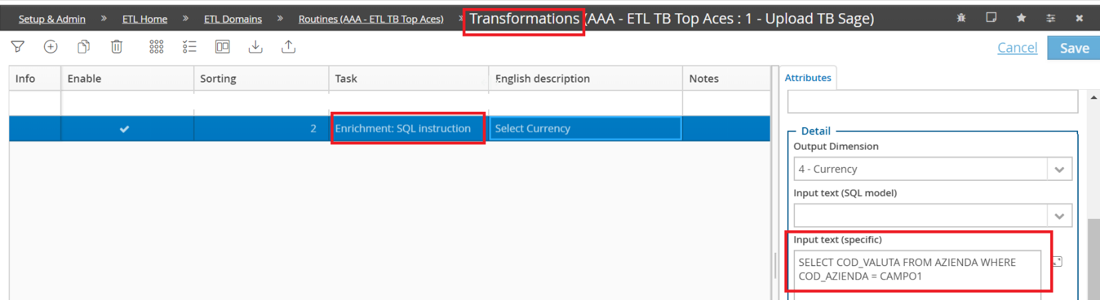
/!\ In this example Entity is the Campo1 (in the dimensions definition)

- Create new column by concatenate others

In this case Campo 22 is the concatenation of Campo 5, Campo 20 et Campo 21 and separator.


